1. **Angular Dependency Injector**: Which is a **tool** provided by angular to inject dependency automatically by angular and we’re not required to create service instance.
2. **How to inform angular of the dependency we need**?
   1. We add a constructor to the class where we need dependency.
   2. Bind the dependency to the class’s property by using typescript shortcut of adding an access specifier (private, public) in front of the name of the argument to constructor instructing typescript that it is not local argument but instance variable.
3. 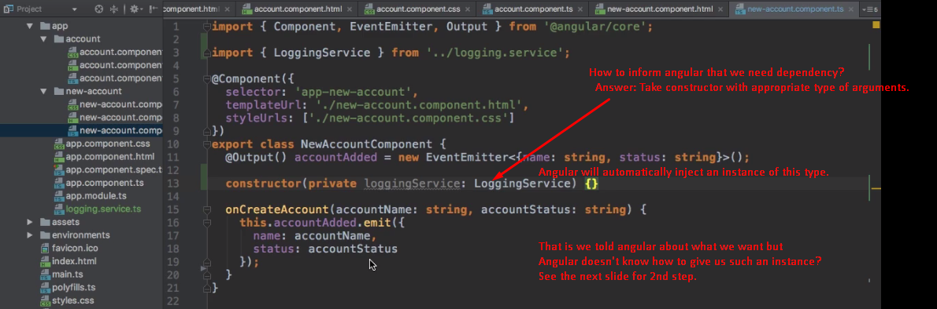
4. **2nd Step**: We need to provide a service. “Provide” simply means we tell Angular how to create service’s instance.
   1. We have to add one additional property to @Component’s configuration object 🡺 providers: [placeHolder] 🡸 PlaceHolder: we have to specify the type of what we want to get provided. 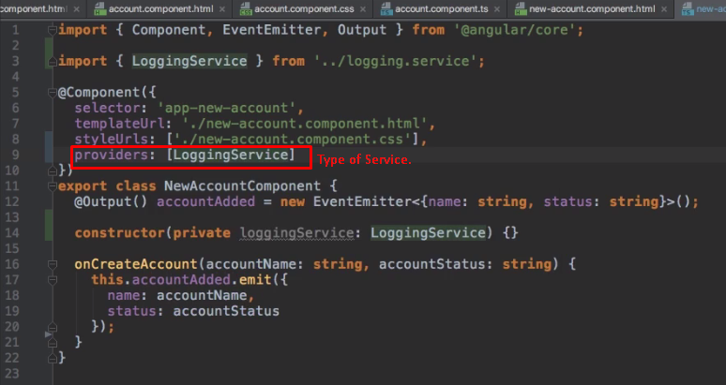
   2. Then angular when analyzing the component, recognizes that it should be able to give us such a LoggingService and it sets itself up to be able to do so and when it builds/constructs the component, it sees that we have to have such an instance and it knows how to give us such an instance.
   3. Now, in our component anywhere, we can access the LoggingService with this.loggingService  
      